GENERAL PURPOSE AND DESCRIPTION:

The purpose of the Planned Development – Mixed Use District (PD-M), hereinafter referred to as “PD-M,” “the District,” or “this District,” is to comply with the City of Bryan Code of Ordinances while establishing alternate development standards set forth in this PD-M for the mutual benefit of both the property owner and the City of Bryan.

  - Coordinating public and private investments for the greatest effect including the public investments already underway in the area;
  - Providing greater connectivity within the district and to adjoining destinations and appropriate transitions to adjoining neighborhoods;
  - Promoting a sense of place by bringing buildings closer to the street where they can interact with pedestrians and be more visible to potential customers;
  - Providing greater market flexibility by allowing a range of commercial and residential uses within the same district; and
  - Ensuring the quality of development through the establishment of urban design standards and providing for a streamlined development review and approval process to facilitate economic development.

For the purpose of establishing development standards for this PD-M, this district shall comply with the City of Bryan Code of Ordinances, except as set forth within this PD-M.

This PD-M is divided into two component sub-districts - the Highway Retail (HR) Sub-District and the General Mixed-Use (MU) Sub-District - as shown on the Regulating Plan (Exhibit I).

- Highway Retail (HR) Sub-District: includes the area with direct frontage along North Earl Rudder Freeway. This sub-district shall contain commercial uses with a focus on design standards to create a more attractive major corridor through Bryan. The design standards will emphasize aesthetic treatments along North Earl Rudder Freeway.
- General Mixed-Use (MU) Sub-District: shall be the area that focuses on transforming internal streets into walkable streets with buildings that line these internal streets and associated parking either provided on-street or around the primary buildings. Development would generally support a walkable mixed-use context along key blocks with a wide mix of commercial including retail, restaurant entertainment, office, hospitality and multifamily uses.

The Regulating Map, Appendix A, establishes the boundaries of the aforementioned sub-districts within this PD-M. The map indicates Type ‘A’ and ‘B’ frontages, and special requirements within the district.

The Conceptual Site Layout and Land Use Plan, Appendix B, is intended to serve as a guide to illustrate the general PD-M vision and is not intended to serve as a final document and may be amended from time to time.

The Planning Administrator or City Engineer or his or her designee(s) shall have administrative approval authority to vary any numerical standard in this Section within 10% of the established requirement specifically to address the following site-specific conditions only:

    - Steep grades on the site
    - Existing utilities and/or easements
    - Existing vegetation that is to be preserved
    - Drainage
    - Accommodate wider sidewalks, trails, or new cross access between properties

Appeals of Planning Administrator or City Engineer decisions and variances shall be heard by the Zoning Board of Adjustment (ZBA) and follow requirements of Bryan Code of Ordinances Section 130-41.

SECTION 1: DEFINITIONS

The following words, terms, and phrases shall have the meanings ascribed to them in Bryan Code of Ordinances Chapter 130, Zoning, except where the context indicates a different meaning. Words and terms not expressly defined in this chapter or Chapter 62 have ordinary dictionary meanings based on the latest edition of Merriam-Webster’s Unabridged Dictionary. When not inconsistent with the context, words used in the present tense include the future; terms used in the singular number include the plural; and phrases used in the plural number include the singular.

Standalone emergency care or urgent care center - an urgent care center is a walk-in clinic focused on the delivery of medical care for minor illnesses and injuries in a stand-alone medical facility outside of a traditional hospital-based or freestanding emergency department (ED). Other names for similar types of facilities include but are not limited to after-hours walk-in clinics, minute clinics, quick care clinics, minor emergency centers, and minor care clinics.

Specialty Hospital - establishments known and licensed as specialty hospitals primarily engaged in providing diagnostic and medical treatment to inpatients with a specific type of disease or medical condition (except psychiatric or substance abuse).

Offices of All Other Miscellaneous Health Practitioners - establishments of independent health practitioners (except physicians; dentists; chiropractors; optometrists; mental health specialists; physical, occupational, and speech therapists; audiologists; and podiatrists).

Place of worship auxiliary use - establishments primarily engaged in operating religious organizations, such as churches, religious temples, and monasteries, and/or establishments primarily engaged in administering an organized religion or promoting religious activities.

Micro-brewery, micro-distillery or winery (with restaurant or retail sales) - establishments that are engaged in the production of beer, spirits, or wine that sell a significant portion those products on site in a restaurant or retail setting.

Hotel (select-service or full-service only) - an establishment categorized as one which offers customary food and beverage facilities and room service or one which offers a breakfast buffet or full-service breakfast menu.

Recording studio - an establishment engaged in production of sound recordings.

Useable Open Space - an area included in any side, rear or front yard or any unoccupied space on the lot that is open and unobstructed to the sky except for the ordinary projections of cornices, eaves or porches and includes, but is not limited to, pocket parks, undeveloped open areas used for passive or active recreations, water features, lakes, ponds, trails, areas containing landscape buffers and screening, landscape islands, playgrounds, plazas and undeveloped floodplain.

Add Multifamily Definition

Pocket Park - a small, accessible space, mostly at grade, which fits into the urban fabric and provides greenery, seating, and other pedestrian friendly elements for use by residents or commercial tenants and guests. A pocket park is privately owned. A pocket park is a spatial amenity for development which contains residential uses to ensure adequate and sufficient open space is provided for residents.

SECTION 2: LAND USES

TABLE 1: Carter’s Creek Town Center PD-M Schedule of Uses
Chart Legend: "P" Permitted Use, "C" Conditional Use | Sub-Districts
USE | HR | MU
PUBLIC AND CIVIC USES
College, university or private school | C-P | C-P
Day care center (Class B & C only) | C | P
Trade and commercial schools | C | C
Essential Municipal Use | P | P
Museum, library or fine art center, art gallery | C | P
Nonprofit organization or institutional | C | C
Stand-alone Urgent care or emergency care centers | P | P
Medical Facilities or Clinics | P | P
Hospital | P | P
Offices of All Other Miscellaneous Health Practitioners | P | P
Stealth telecommunications tower | See Chapters 62 & 130, Bryan Code of Ordinances | See Chapters 62 & 130, Bryan Code of Ordinances
Telecommunications antenna (on structure) | See Chapters 62 & 130,  Bryan Code of Ordinances
RETAIL USES
Amusement, indoor | P | P
Amusement, outdoor , excluding carnivals | P | P
Amusement, outdoor (carnivals) | C
Bar, tavern, cocktail lounge; club, private or teen | P | P
Fitness Center | P | P
Micro-brewery, micro-distillery or winery  (with restaurant or retail sales) | P | P
Park or playground (public or private) |  | P
Retail sales and services | P | P
Restaurant, café, cafeteria (without drive thru) | P | P
Restaurant (with drive thru) | P | C
Shooting or weapons firing range (indoor only) | C | C
Hotel (select-service or full-service only) | P | P
Bank, financial institution (without drive thru) | P | P
Bank, financial institution (with drive thru) | P | C
Offices, professional and administrative | P | P
Animal hospital  (no outdoor runs; overnight boarding limited to pet treatment) | C | C
Book, stationery stores or newsstand | P | P
Dance studio | P | P
Dog training school | C | C
Kiosk | C | C
Liquor or package store | P | P
Pet day care (no overnight lodging) | P | P
Pharmacy/drugstore (with drive thru)_ | P | C
Pharmacy/drugstore (without drive thru) | P | P
Recording studio | P | P
Retail Services (including incidental services) | P | P
New auto accessory and parts sales store  (without outdoor Display or storage) | C | C
Automobile Sales (including service and parts) | C | C
Convenience store  (with motor fuel sales) | C | C
Electric Vehicle (EV) charging stations | P | P
Parking lots or garages | P | P
RESIDENTIAL USES
Assisted Living (min. 30 beds) |  | C
Multifamily dwelling (need def. 20+ units, attached) |  | P
OTHER USES
Accessory structures | P | P
Sidewalk and outdoor display | See Sections 130-3 & 130-34(m)  (refer to C-2 District)
Limited outdoor storage | See Sections 130-3 & 130-34(m)  Requires SDRC site plan approval
Common open space, recreational building, community center and other similar multifamily amenities |  | P

These uses shall not be allowed:
XX

SECTION 3: PHYSICAL DEVELOPMENT STANDARDS

This PD-M provides for two different sub-districts designed to provide an orderly land use transition.

- Lot Area, Height, and Setback Requirements

Standard | HR | MU
Building Setbacks (measured from the property line) (minimum)
North Earl Rudder Freeway Frontage Road | 75 feet | N/A
Primary street (Type ‘A’ street or Type ‘A’ easement) | 5 feet | 5 feet  15 feet maximum
All other streets | 10 feet | 10 feet
Side or rear | 5 feet | 5 feet
Parking setbacks (from Type ‘A’ street or Type ‘A’ easement) | N/A | Behind the primary building or 5 feet (whichever is greater)
Parking setbacks (secondary street) | 50 feet along North Earl Rudder Freeway | Behind the front façade of the building along the street or 10 feet min.; whichever is greater.
Parking frontage (max. along Type ‘A’ Street or Type ‘A’ Easement) | 30% | 20%
Minimum lot size | 30,000 square feet | 30,000 square feet
Minimum lot width | 120 feet | 120 feet
Maximum building height | 2 stories and not to exceed 35 feet | 4 stories and not to exceed 60 feet
Minimum percent of usable open space (may be designated public or private) | 15% of the overall sub-district | 15% of the overall sub-district
Maximum lot coverage | 75%. | 75%

- Off-Street Parking

- Site Design Standards (driveways and cross access)

  - One (1) primary access point shall be allowed onto the North Earl Rudder Freeway frontage road, as shown on the site plan with a median to accommodate12’ minimum landscaping. All other driveways onto North Earl Rudder Freeway shall be allowed based upon the TxDOT’s access management standards.

  - Cross-access easements:
- Cross-access easements shall be a minimum of 24 feet wide and shall be provided to adjoining lots within this PD-M regardless of the development status of the adjoining lots. All drive aisles and sidewalks shall be designed, and easements conveyed to connect to existing or future drive aisles, sidewalks, trails, or parks on adjacent parcels.
- Location of the cross-access easements shall be established during the site plan.

- Building Design Standards

  - Façade Composition: Building facades that face a public street or private street with a public access easement shall comply with the minimum requirements illustrated in the diagram below.

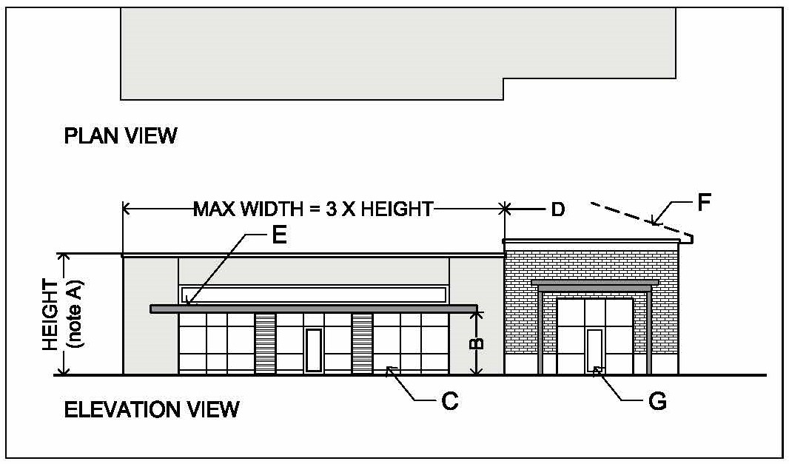  Figure X.X Façade Composition | DIAGRAM ANNOTATIONS:  - Façade height shall be minimum of 15 feet for parapet wall, or 12 feet for a sloped roof eave.  - Storefront glazing to be minimum 9 feet high and shall extend within 0-16” of the sidewalk grade.  - Minimum glazing as a percentage of the total wall area shall be 25%  - Walls that exceed a height to width ration of 1:3 shall incorporate a change the façade massing and articulation which shall include the following: a change in the horizontal plane with a minimum one-foot recess or projection from the adjacent wall, a change in the wall height of two feet, a change in exterior wall material, a change in the storefront opening proportions, and change in the shading device configuration (type, height, extension, color).  - A shading device shall be incorporated along a minimum of 50% of the façade length.  - Optional sloped roof  - Doors to be commercial grade with minimum 40% glazing.
  - Building Orientation and Entrances:
- Buildings with frontage along Type ‘A’ streets shall be oriented to have their longer sides along Type ‘A’ streets.(Please provide more details about type A and B streets)
- Buildings shall have at least one entrance along the Type ‘A’ street.
- Building entrances shall have a pedestrian connection from the entry to the public sidewalk on a Type ‘A’ street.
- Secondary entrances from a rear parking lot may also be provided.

  - Building components:
- Glazing:
  - Buildings shall incorporate commercial grade storefront window systems. Glass shall be clear or lightly tinted. Reflective (mirror) glass is not permitted.
  - Minimum glazing as a percentage of the total facade area shall be 25%.
- Roofs: roofs shall be low slope membrane roofs behind a parapet wall, and/or sloped hip or gable roofs having a minimum slope of 4:12 and a maximum slope of 8:12.
- Roof Top Mechanical Equipment: exterior building walls shall be tall enough to shield all rooftop mechanical equipment from the view from any adjoining public street. Other screening devices such as louvered panels and any treatments that are compatible with the building's architecture may be considered on a case-by-case basis with approval by the Planning Administrator or his or her designee.
- Awnings and Shading Devices: awnings, projecting roofs, and porches shall be permitted as shown in Figure XX Shading Devices. No fabric awnings shall be allowed in this PD-M District.
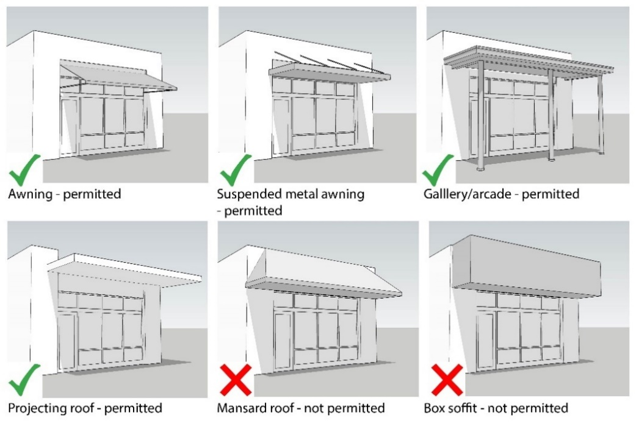
Figure XX Shading Devices

- Landscaping and Buffer Requirements: Standards in Section 62-429 Landscaping Requirements of the City of Bryan Code of Ordinances shall apply to this PD-M District with the following modifications:

  - North Earl Rudder Freeway Buffer Zone: Development shall occur outside of this prescribed area and be limited to landscaping, utilities, stormwater detention facilities, and pedestrian walkways. The buffer zone is measured from the property line adjoining the North Earl Rudder Freeway frontage road.

  - Parking lot landscaping requirements: The following is intended to build upon on the requirements set forth in Section 62-429.
    - Provide planter islands as indicated in Sec 62-429 with the following modifications:
      - 100% of required planters to have shade trees of a moderate to rapid growth rate.
      - In no case shall there be more than 10 parking spaces in a row without a planter and tree; disperse trees throughout parking lots to achieve maximum shade coverage.
    - Parking lots that face a Type ‘A’ street as designated on the Carter’s Creek Town Center Regulating Plan, and along the North Earl Rudder Freeway frontage road, shall be screened by dense shrubbery or hedges having year-round foliage. Shrubs are to be planted in a landscape strip of at least six feet in width arranged in an alternating/staggered pattern formed by two rows, two feet apart on center, each of which is made up of shrubs three feet on center. At the time a request for a certificate of occupancy is made, shrubs and hedges shall be at least three feet in height.

  - Ground mounted equipment screening: all ground-mounted mechanical equipment shall be screened within a wall matching the building in material and color, or if located away from view from the public right-of-way, landscaping may be utilized.

- Usable open space standards: a minimum of 15% of the land area in each sub-district shall be designated as usable open space which shall meet the following criteria:

  - Improvements: usable open space shall consist of landscaped open space areas that are intended for passive or active enjoyment and may include seating, fountains, gardens, pergolas, playground, small park, open space amenities and café dining. Up to 75% of the required area may be paved with concrete or unit pavers (asphalt not permitted). Paved areas shall be provided with shade trees not less than one per 500 square feet of paved area.

  - Location: usable open space shall be located along a public street or public easement, adjacent to a building entrance, or along a public trail useable in floodplain and maintained detention areas. Parking lot landscaping, or open space that is surrounded by parking lots, or landscaping within the public right-of-way or public access easement, do not count toward this requirement.

- Sign regulations: standards in Chapter 98-46, Sign Regulations, of the City of Bryan Code of Ordinances shall apply to this PD-M District, with the following modifications:

  - A maximum of one monument sign shall be permitted per lot.
  - In addition, to individual lot signage the PD-M District shall have additional signage per the following restrictions:
  - This District shall be granted one multi-tenant pylon sign for the purpose of identifying the development “primary development signage” and allowing space for tenants up to a maximum of 50 feet in height with a minimum distance from the right-of-way of 30 feet..

  - This District shall be allowed up to two secondary multi-tenant signs along the Earl Rudder Service Road for the purpose of identifying the development and tenant(s) (“Secondary Signage”) based upon the following restrictions:
  - The tenant serving the secondary sign shall be greater than 20,000 square feet and have Road A frontage of at least 325 LOGICALLY THIS WILL BE CLOSER TO ACCES ROADS DUE TO HAVING BIG TENANT ON THOSE AREAS. THIS HAS TO FOLLOW WHATEVER THE TXDOT ALLOWS US. AM I WRONG?
  - Secondary Signage shall be at least 325’ from Primary Development Signage or other Secondary Signage.
  - Secondary Signage shall have a maximum sign face of up to 210 square feet for a single-user sign or 300 square feet for a multitenant center sign. A maximum size of 20 square feet for each tenant is allowed for tenant signs on a multitenant center sign, with up to a maximum of six tenant signs. This size of the tenant sign is separate from the calculation of the size of the Primary Development Signage. Secondary Development Signage is limited to a maximum of 25 feet in height with a minimum distance from Earl Rudder Service Road of 100’. THIS WILL BE I THE MIDDLE OF THE PARKING LOT? ALL MONUMENT SIGNS SITS ON LANDSCAPING ISLE? THAT’S WHY I PUT 30 FEET.
  - The minimum distance between signs allowed under this section shall be no less than 325 feet.

  - Each tenant shall be allowed tohave a façade signage on the buildings per City of Bryan signage standards, or as set forth below:
  - Projecting signs: building occupants that are classified as retail uses for entertainment or eating, may utilize a projecting sign as all or part of the area allowance for wall signs. Projecting signs are to be double sided and may incorporate LED neon type lighting. Examples of projecting signs are shown in Figure XX.
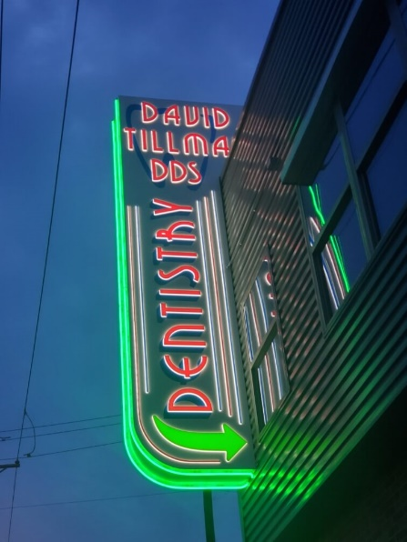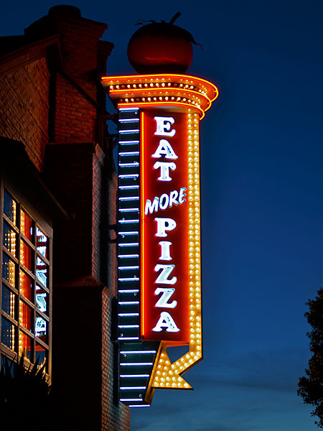
Figure XX. Examples of projecting signs

  - Blade signs and canopy signs: In addition to the signs permitted in Chapter 98, each tenant space shall be permitted to have one blade sign OR canopy sign located within 10 feet of the occupant entry door. The area of the Blade or canopy sign shall not count against the area of other permitted signs.
    - Blade signs: Shall be mounted to the building wall and project at a 90 degree angle. Signs shall not exceed 8 square feet and have a head clearance of 8 feet from the sidewalk elevation. See example in Figure XX.
    - Canopy sign: Shall be mounted to the underside of a fixed canopy or awning structure. Signs shall not exceed 8 square feet and have a head clearance of 8 feet from the sidewalk elevation. See example in Figure XX.

Figure XX. Left, example blade sign; right, example canopy sign

- Street Design and Trail Standards:

  - Trails and Open Space: trails shall be installed in the locations shown on the attached Regulating Plan. The following additional standards shall apply:
    - Trails shall be of concrete construction of sufficient thickness to ensure long-term durability and have a minimum width of 10 feet with 3 foot fall away zones on both sides. Trail segments shall be installed concurrently with development of the adjacent street and to recording of the final plat.
    - A Property Owner’s Association (POA) shall be established with direct responsibility to, and controlled by, either by developer or the property owners involved to provide for operation, repair and maintenance of all common area/open space and storm water detention areas in this PD-M District.
    - This District shall integrate an off-street trail system providing pedestrian and bicycle connectivity within the two sub-districts. The trail system shall include a meandering path for pedestrians and bicycles with a minimum width of 10 feet. The trail system shall integrate with the required sidewalks to create a continuous path throughout the District.
    - A small pocket park shall be located as shown on the Regulating Map and the Conceptual Site Layout to serve as an integral continuation of the trail system connection.
    - The pocket park may also function as drainage/detention pond so long as such open space serves as an amenity during non-peak rain events.

  - Transportation
    - Streets – any public and/or private streets or driveways shall meet the minimum standards as set forth in the Bryan/College Station Unified Design Guidelines Manual. In addition, cross-sections that encourage urban pedestrian-oriented development shall be provided. Review and approval of submitted designs shall be the responsibility of the City Engineer or his or her designee.

- Landscaping: standards in the City of Bryan Code of Ordinances regarding landscaping standards shall apply to this PD-M, with the following modifications:

  - Tracts 1 & 2 – Street trees shall be planted along all streets within these Tracts to the following standards:
- Trees shall be spaced at a maximum of 50 feet apart on center between the sidewalk and back of curb (or edge of pavement) along the North Earl Rudder Freeway frontage road in accordance with a Master Landscaping Plan, which shall be completed and approved by the Planning Director and Developer prior to issuing any site plan approvals.
- Trees shall be spaced at a maximum of 40 feet apart on center between the sidewalk and back of curb (or edge of pavement) along internal streets.
- The spacing of trees may be modified to accommodate the tree species spread.

- Trails and open space shall be credited against minimum landscaping requirements.

- The Planning Administrator or his or her designee may make minor variations to tree spacing in parking fields to accommodate irregular lot configurations.

- All common area sidewalks and trees, shall be maintained by the POA, or property owner

- Lighting and Amenities

  - If the developer incorporates at least two pedestrian amenities such as outdoor dining areas, covered gathering spaces, outdoor seating areas, or other similar features, then the developer shall be granted a reduction of 15% of the landscape area for the integration of such pedestrian amenities for each site development project.

- Signage and Branding

  - A master signage plan will be created for the development, prior to issuance of any site plan approvals. The master signage plan will include all signage for the entire project using a cohesive palate. Tract 3 may have separate monument signage on its lot.

  - A hardscape and landscaping plan will be created for the development. The site development plans will include all landscape and hardscape for the entire project using a cohesive palate.

- Phasing

The Multifamily development shall be limited to a maximum of 500 units. The developer should build 80 square feet of commercial for every unit constructed and the infrastructure to service the Highway Retail – District within 48 months of the Certificate of Occupany for any unit of multifamily.

SECTION 4: SUBDIVISION OF LAND

The subdivision of land in this PD-M District shall be allowed by Chapter 110, Subdivisions, of the City of Bryan Code of Ordinances, with the exceptions or additions to ordinary standards found in this document.

APPENDIX A – REGULATING PLAN

APPENDIX B - Conceptual Site Layout and Land Use Plan

